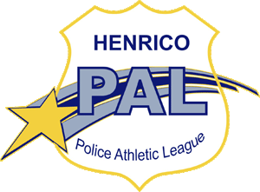

Henrico PAL
Child Release Authorization Form

I, _____________________________, give my authorization for the individual(s) below to pick up my child, _______________________________, from the Henrico PAL program in my absence.
Name: Contact #: Relationship to Child:

Parent Signature___________________________ Date___________________________
Appropriate paperwork such as custody papers shall be attached if a parent is not allowed to pick up child. Section 22.1-4.3 of the Code of Virginia states that unless a court order has been issued to the contrary the noncustodial parent of a student enrolled in a public school or day program center must be included, upon the request of such noncustodial parent, as an emergency contact for events occurring during school or day program activities.

